NBA PE Extra-Curricular timetable January - February
After school 3.10 - 4.00pm

Monday | Tuesday | Wednesday | Thursday | Friday
  Basketball  (BGI)  Year 10  CNat Sport Science  (JEM and MHL) |   Year 7&8 Handball  (MHL)  Year 11  CNat Sport Science  (BGI) | Girls football fixtures  (CYO and VJO)    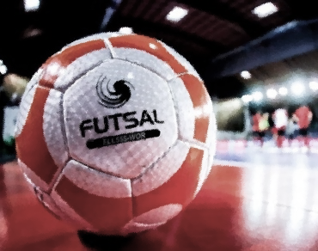  Futsal  (JEM)    Just Dance  (VJO) | No clubs – staff meetings | 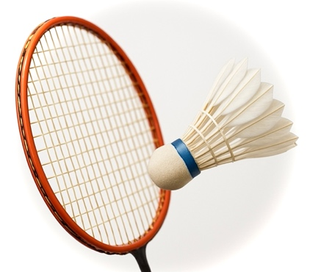  Badminton  (ABA)

